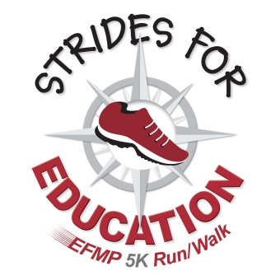
SPONSORSHIP LEVELS
5th ANNUAL STRIDES FOR EDUCATION
VIRTUAL 5K RUN/WALK
Friday, Oct. 23 through Sunday, Oct. 25

As a race sponsor, you support the Education Foundation of Morris Plains (EFMP) and educational opportunities for the students of the Morris Plains School District. Your generous sponsorship means your company receives goodwill as well as exposure to walkers, runners and supporters from Morris Plains and the surrounding area.

GOLD SPONSORSHIP: $1,000 (1 sponsorship available)
- Premier placement (name and logo) on reusable runners’ bags.
- Company name and logo prominently placed on official race banner, which will be promoted as a photo spot for participants to take selfies.
- Promotion as Gold Sponsor in all marketing and PR efforts and the EFMP website.
- Your company’s promotional materials or giveaways included in the runner race packets.
- An EFMP Supporter window decal for your place of business.

SILVER SPONSORSHIP: $500 (Limited number available)
- Prominent placement (name and logo) on reusable runners’ bags.
- Company name placed on official race banner, which will be promoted as a photo spot for participants to take selfies.
- Promotion as a Silver Sponsor in all marketing and PR efforts and on the EFMP website.
- Your company’s promotional materials or giveaways included in the runner race packets.
- An EFMP Supporter window decal for your place of business.

BRONZE SPONSORSHIP: $250
- Company name placement on reusable runners’ bags.
- Company name and logo on official race banner, which will be promoted as a photo spot for participants to take selfies.
- Promotion as a Sponsor in all marketing and PR efforts and on the EFMP website.
- An EFMP Supporter window decal for your place of business.

To learn more about the Strides for Education Virtual 5K Run/Walk, visit www.educationfoundationmp.com.

