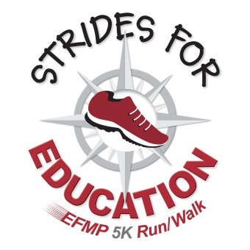***6th ANNUAL STRIDES FOR EDUCATION***

***Hybrid 5K RUN/WALK and Fun Run***

**In person: Sunday November 14, 2021  
 8:30 a.m. fun run, 9:00 a.m. 5k start  
 New flat course starting at Simons Park**

**Virtual: Friday, Nov. 12th through Sunday, Nov. 14th**

As a race sponsor, you are supporting the **Education Foundation of Morris Plains (EFMP)** and funding innovative educational opportunities for the students in the Morris Plains School District. Your generous support means your company receives goodwill as well as **exposure to walkers, runners and supporters** from Morris Plains and the surrounding area.

**Race Sponsor: $1,000**

* Company name and logo prominently placed on the official race banner, which will be promoted as a photo spot for participants to take selfies.
* Sponsorship thank you in the Drawstring Backpack given to each participant.
* Promotion as Race Sponsor in all marketing and PR efforts and the EFMP website.
* Your company’s promotional materials or giveaways included in the runner race packets.
* An EFMP Supporter window decal for your place of business.

**Kilometer Marker Sponsor: $500 (5 available)**

* Company name placed on official race banner, which will be promoted as a photo spot for participants to take selfies.
* Sponsorship thank you in the Drawstring Backpack given to each participant.
* Promotion as a Kilometer Marker Sponsor in all marketing and PR efforts and on the EFMP website.
* Your company’s promotional materials or giveaways included in the runner race packets.
* An EFMP Supporter window decal for your place of business.

**Supporter: $250**

* Company name and logo on official race banner, which will be promoted as a photo spot for participants to take selfies.
* Support acknowledgement in the Drawstring Backpack given to each participant.
* Promotion as a Supporter in all marketing and PR efforts and on the EFMP website.
* An EFMP Supporter window decal for your place of business.

**To learn more about the Strides for Education Virtual 5K Run/Walk, visit www.educationfoundationmp.com.**

